|  |
| --- |
| Github Demo |

Specifications

The engineering team would like to keep track of events happening in its repos. The team has asked you to create an app which shows selected events types from the Github events api

<https://api.github.com/repos/:owner/:repo/events>

The application should allow the user to specify an owner, a repo, and an event type and then display matching events from the Github events API.

For each matching event, show the event type, actor information, and timestamp of the event. You may choose to show additional information specific to each event type to provide more details.

1. The team is much more concerned with having a functional app than "look and feel" concerns, feel free to prioritize accordingly.
2. For the purpose of this exercise you can assume that the repo access is public and you don't have to worry about authentication.

Please set aside a couple of hours to focus on building the app, but do not spend too much more time than that. We're most interested in where you end up, not necessarily having a "finished" app.

The final product should include:

* Well-organized code
* A git commit history tracking progress
* Unit tests
* Demonstrated understanding of the language and any frameworks used
* Documentation covering how to setup and run the application



Design Considerations

Since creating a set of POJOs to represent the JSON model is both inefficient from a runtime standpoint (incurs gc), it is also brittle from a design perspective.

Reification of what is essentially a String representation into Serializable Objects wastes disk space and CPU cycles.

Serialization of JSON into BSON is a needless expense.

Additionally , serialized objects are fraught with well-known security risks related to streaming.

Exploits include:

ObjectInputStream.readObject()

ObjectOutputStream.writeObject(Object o)

By contrast, string-manipulation logic is readily adaptable to (the likely) changes to of Github's APIs.

Additionally, the approach covered in this document uses core Java 8, and no frameworks are being used.



Use Case (restated as a synopsis)

1. Allow end-user to specify: Owner; Repo; Event-type

2. Display matching events from Github's Events API.

3. For each matching event show: Event type; Actor info; Timestamp(s)

4. Show contextual event-type info as desired.

<https://api.github.com/repos/:owner/:repo/events>



ProcessBuilder – Runtime.getRuntime().exec()

Java’s canonical mechanism to run a Shell (OS) Process within a Java application’s main processing thread of execution. Is either an instance of ProcessBuilder, or Runtime.getRuntime().exec().

As a matter of preference, we utilize the latter approach.

This application goes low-level to the JVM’s representation of an OS process – this is a process, not a “native thread”, nor it is a so-called “green thread”.

The app utilizes the Runtime.getRuntime().exec() mechanism in three places: To acquire the Github user’s identity; To find all of that user’s Repositories; To find of the associated Events with the Repo, as stipulated by the end user (the user of the application).

In each use case, cURL is being delegated-to by the application, under the auspices of Java’s canonical Runtime.getRuntime().exec() mechanism.

The Runtime.getRuntime().exec() makes a delegating call to a pair of utility ßash scripts (in two of the more complex situations which involve the transference of CLI argument lists). The ßash scripts simplify the Java application’s invocations of the Github endpoints which take “arguments”.

In the most basic retrieval – the Github endpoint for a Repo owner’s identity – the endpoint’s invocation is called without arguments (and no ßash script is necessary, as the call is opaque).

The next page shows a screen shot of the simpler approach. Since the method takes up an entire page, it will first be presented in its entirety, then broken into two sections for discussion.



Ownerbio, overview

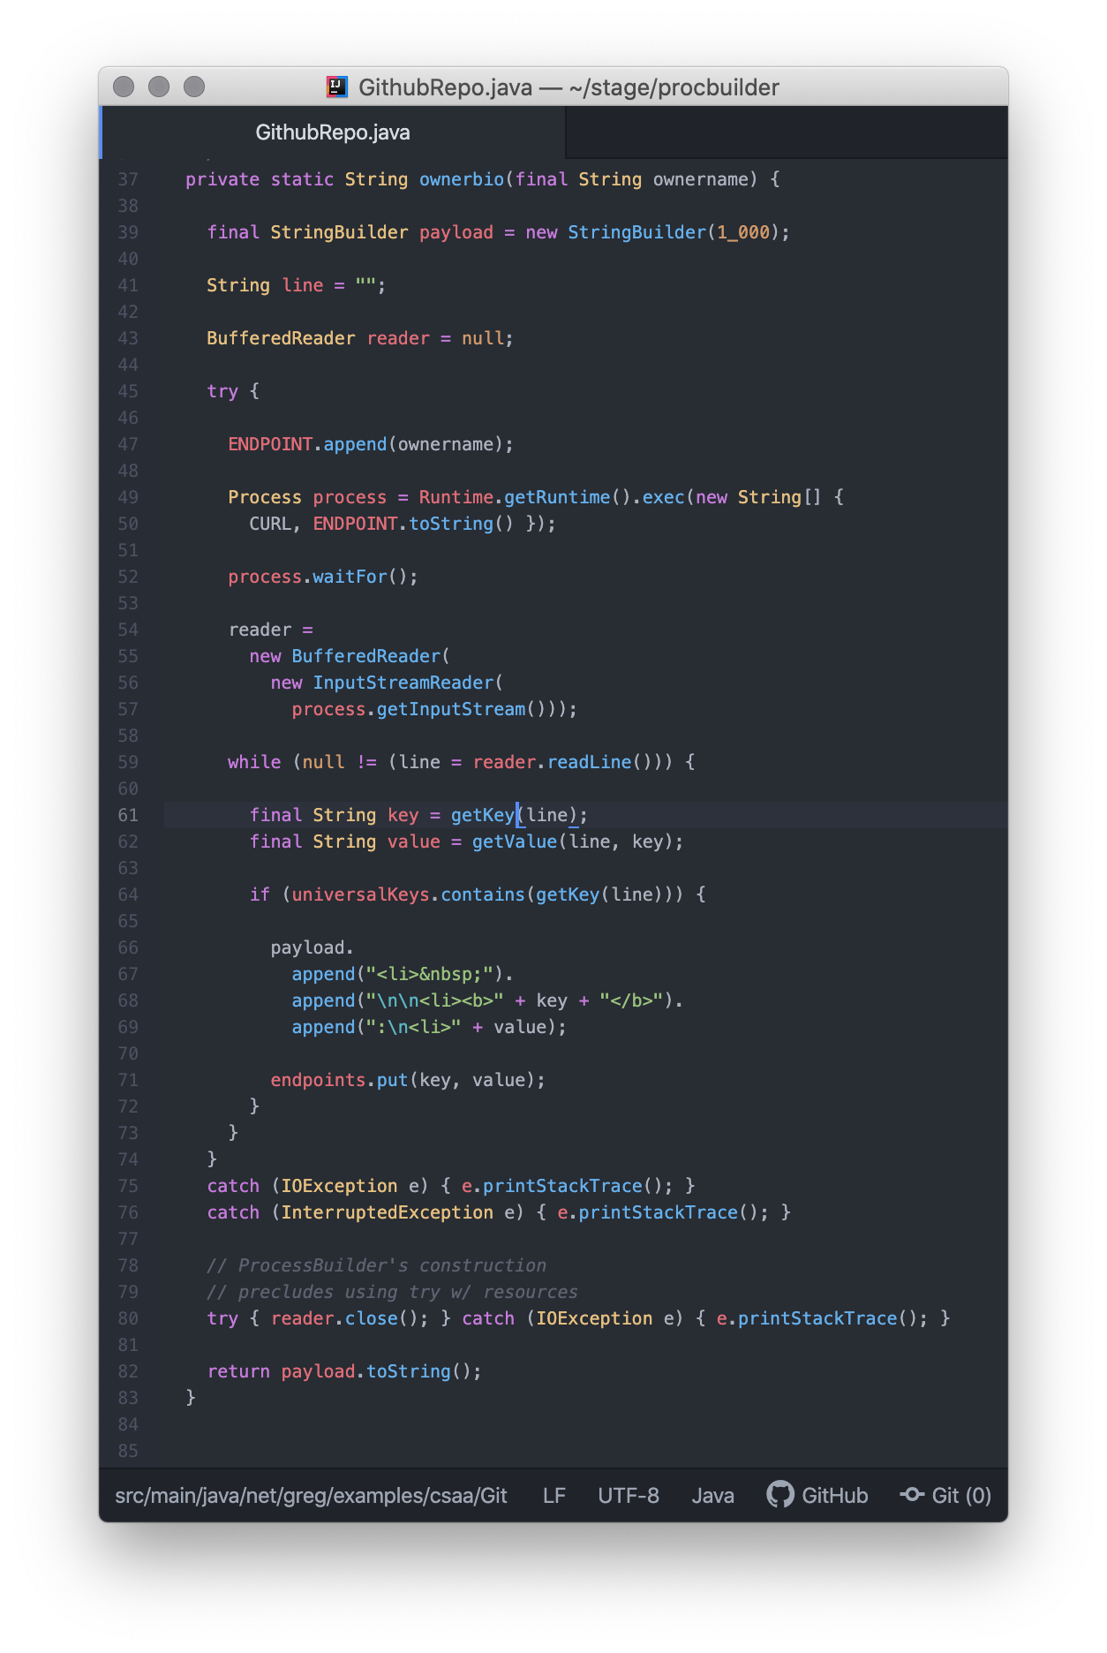

Ownerbio, Part One: the Setup

The logic being discussed belongs to the application’s class-level (static) ownerbio() method which calls an endpoint without any arguments.

A Process instance emits to stdout (a stream). The Consumer of that I/O stream is shown on lines 54-7.

The endpoint is pre-fab (line 47). The Repo owner’s identity (CLI, from the end-user) is appended to the endpoint.

Logic on lines 49-50 constructs the OS Process using the endpoint designation by asking the Java Runtime (singleton-per-JVM) factory for an OS Process.

On line 52, a blocking call is made to allow the acquisition data from a call to Github’s endpoint data to stream-back in one response.

The code on lines 54-57 accept/and consume the stream.

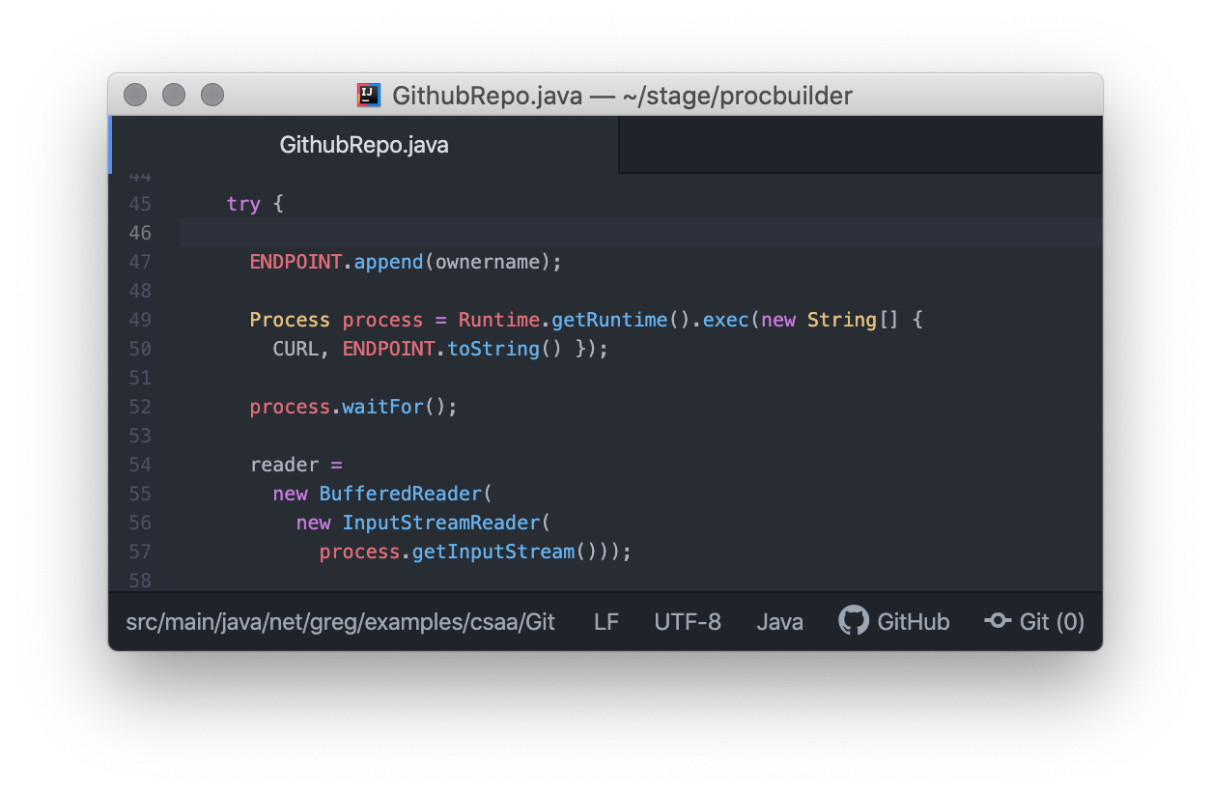

Ownerbio, Part Two: the Ingress

Processing to ingest the payload from the Github endpoint call/invocation starts on line 59.

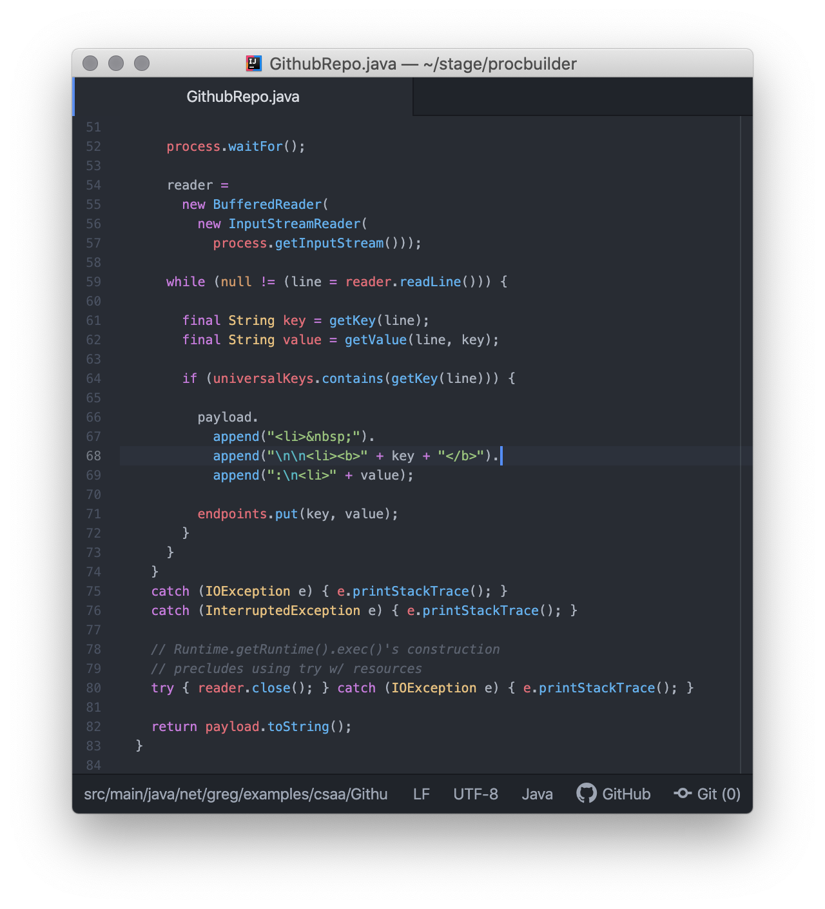



Repos, overview

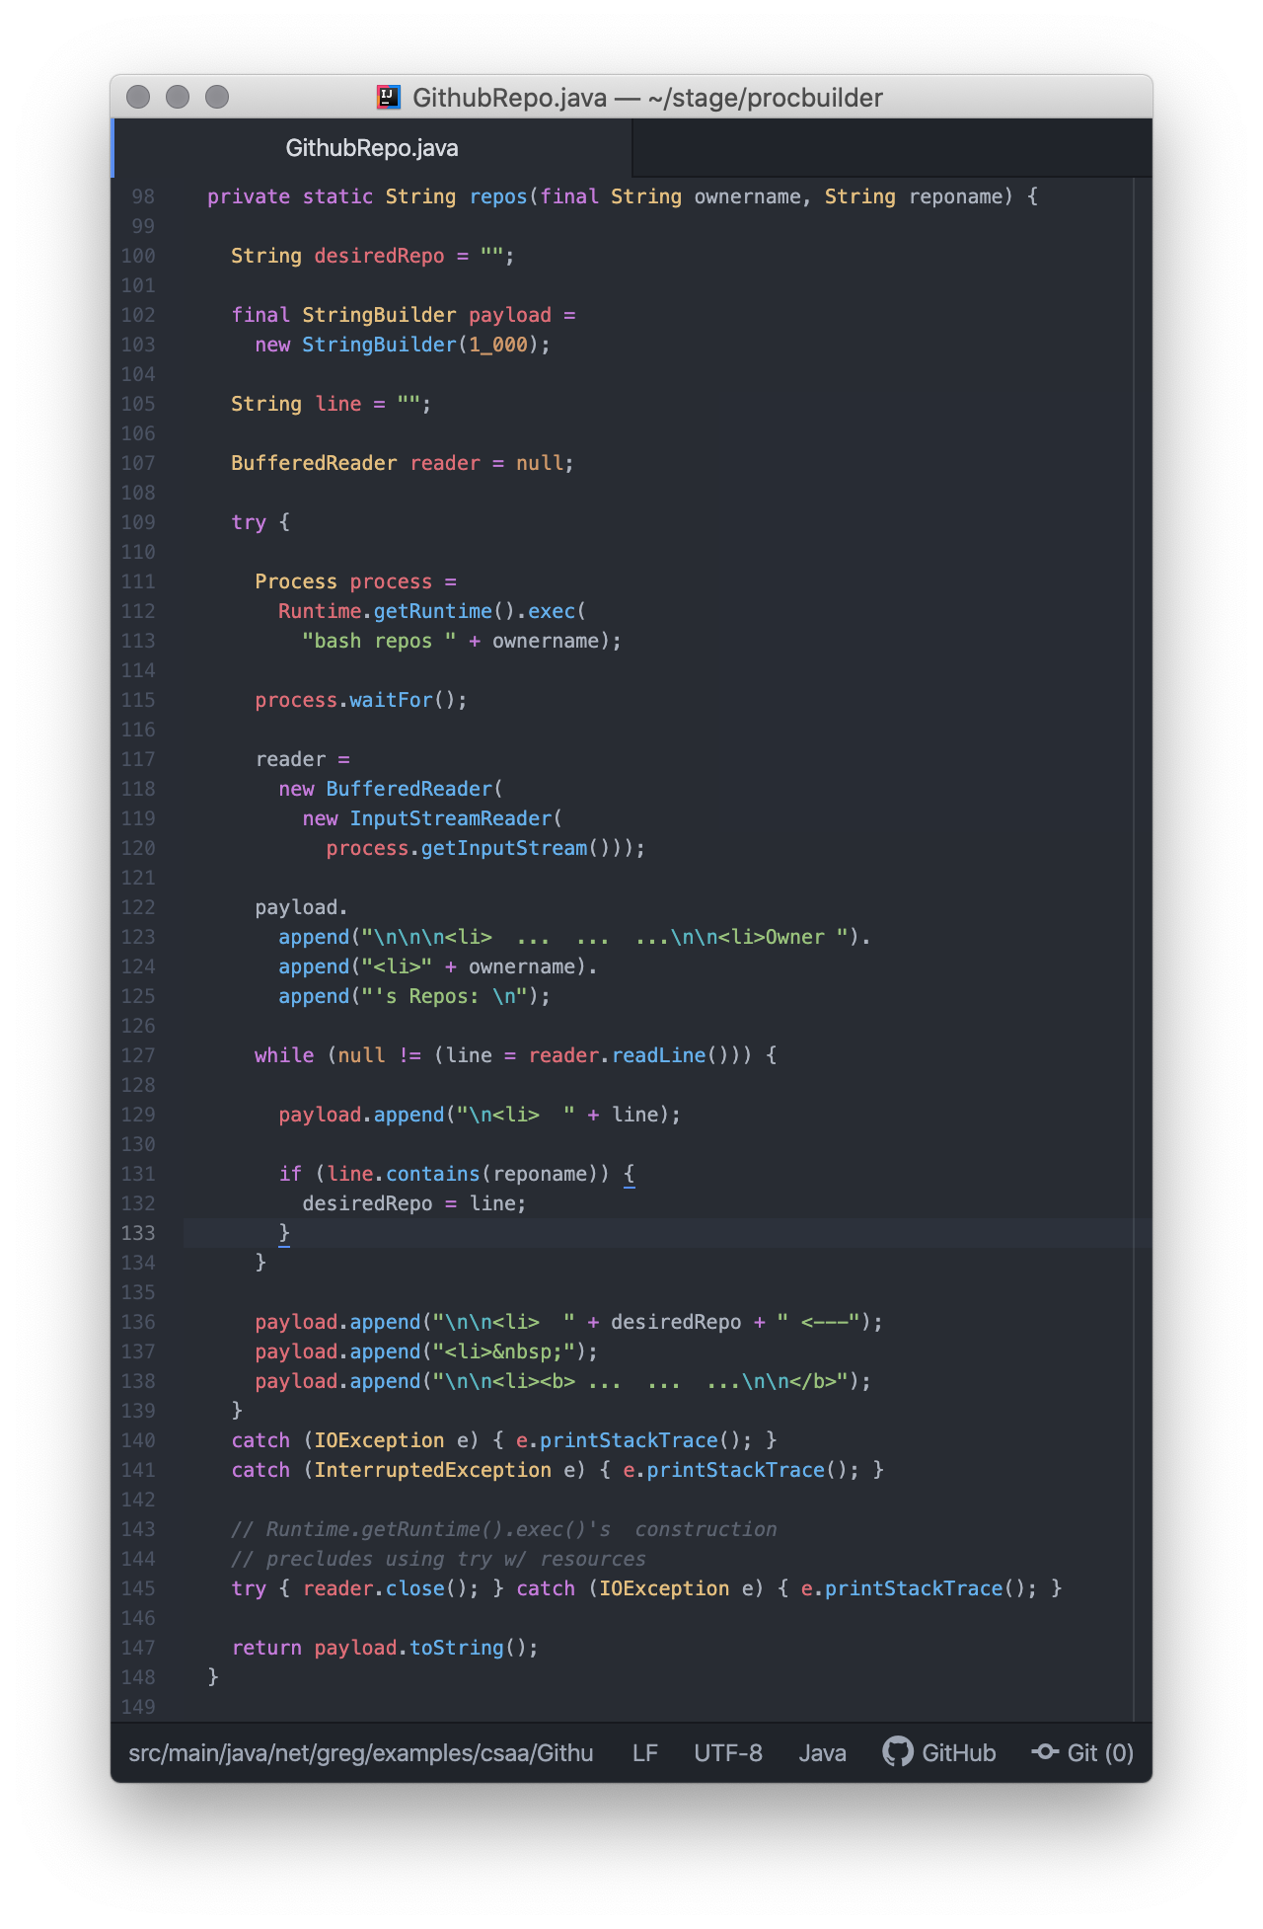

Repos, Part One: the Setup

The logic being discussed belongs to the application’s class-level (static) ownerbio() method which calls an endpoint without any arguments.

A Process instance emits to stdout (a stream). The Consumer of that I/O stream is declared, but not assigned on line 107.

The endpoint is contained in a ßash script named repos (lines 111-113) is installed in the Runtime factory call and results in an OS process.

Logic on lines 111-113 constructs the OS Process using the endpoint designation by asking the Java Runtime (singleton-per-JVM) factory for an OS Process.

On line 115, a blocking call is made to allow the acquisition data from a call to Github’s endpoint data to stream-back in one response.

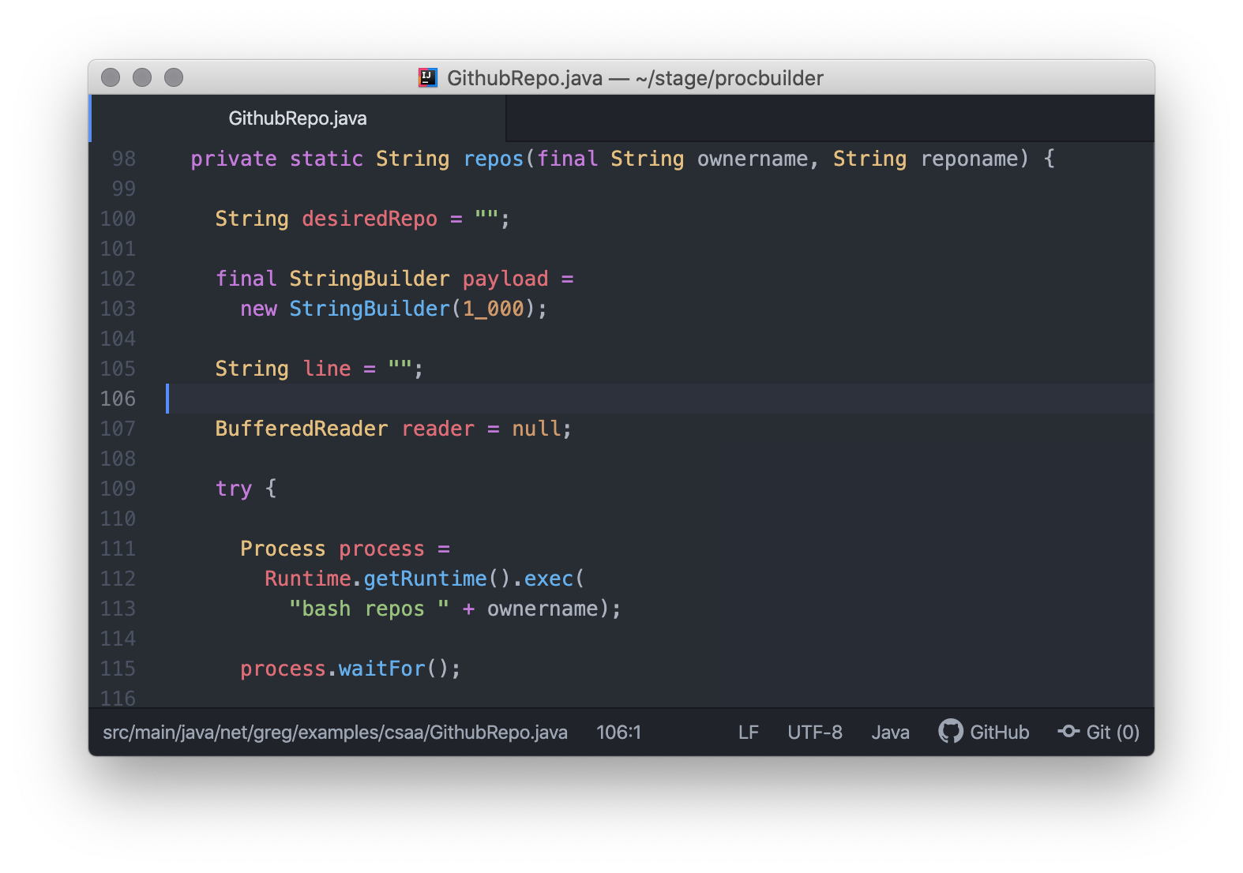

Repos, Part Two: the Ingress

Processing to ingest the payload from the Github endpoint call/invocation (happens inside a ßash script) starts after the blocking call on line 115.

The stream is consumed (lines 117-120) and filtering logic chooses the content to retain, based on custom business needs.

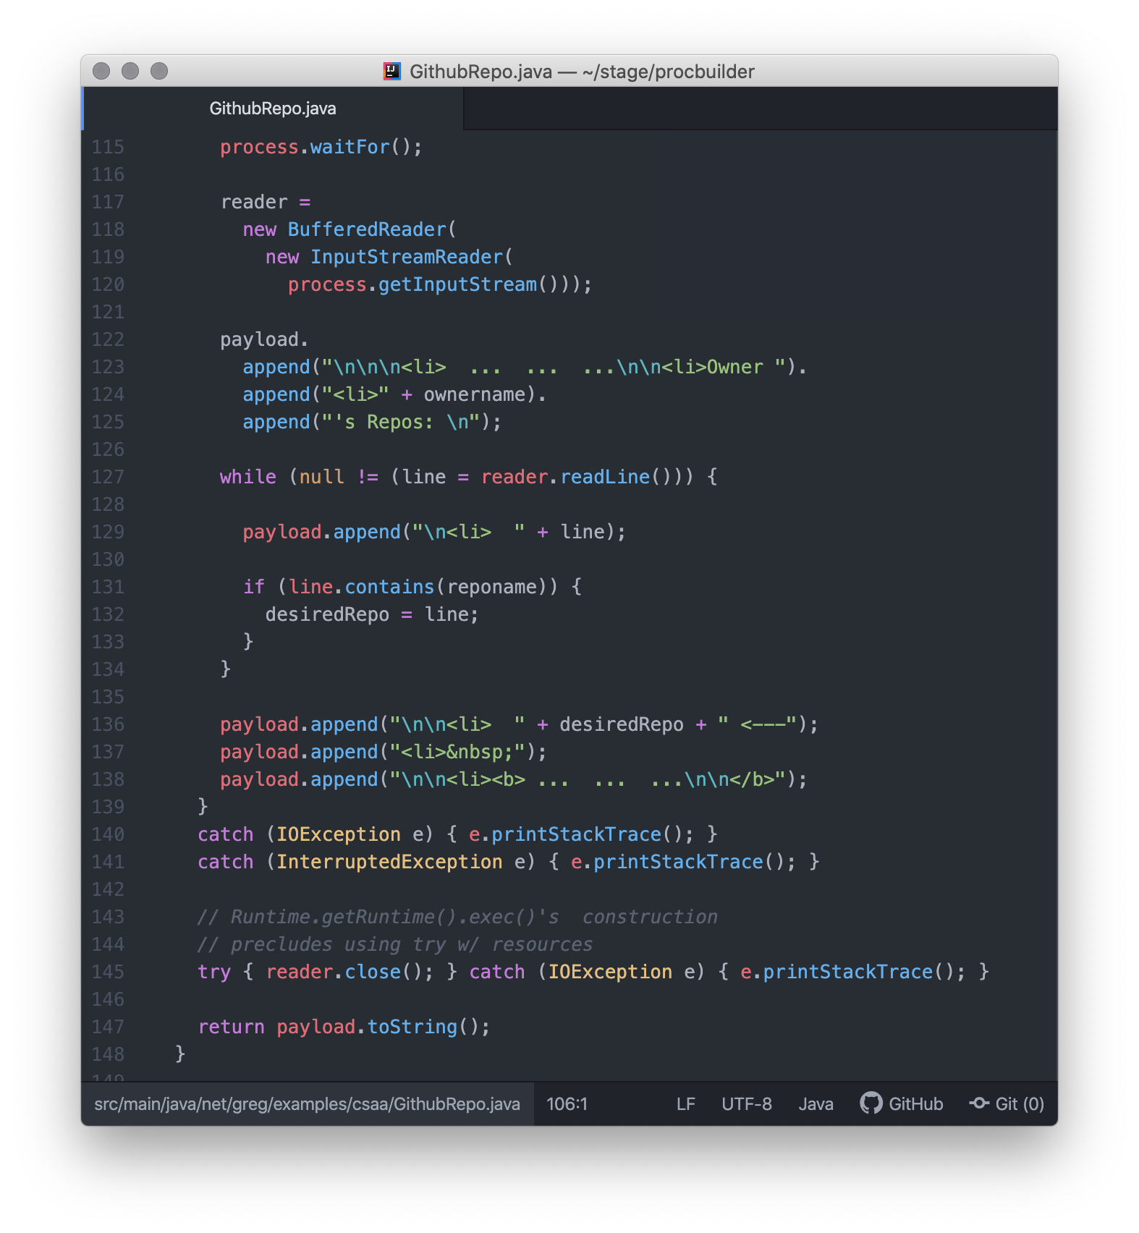

Application in Operation (8 screen shots)

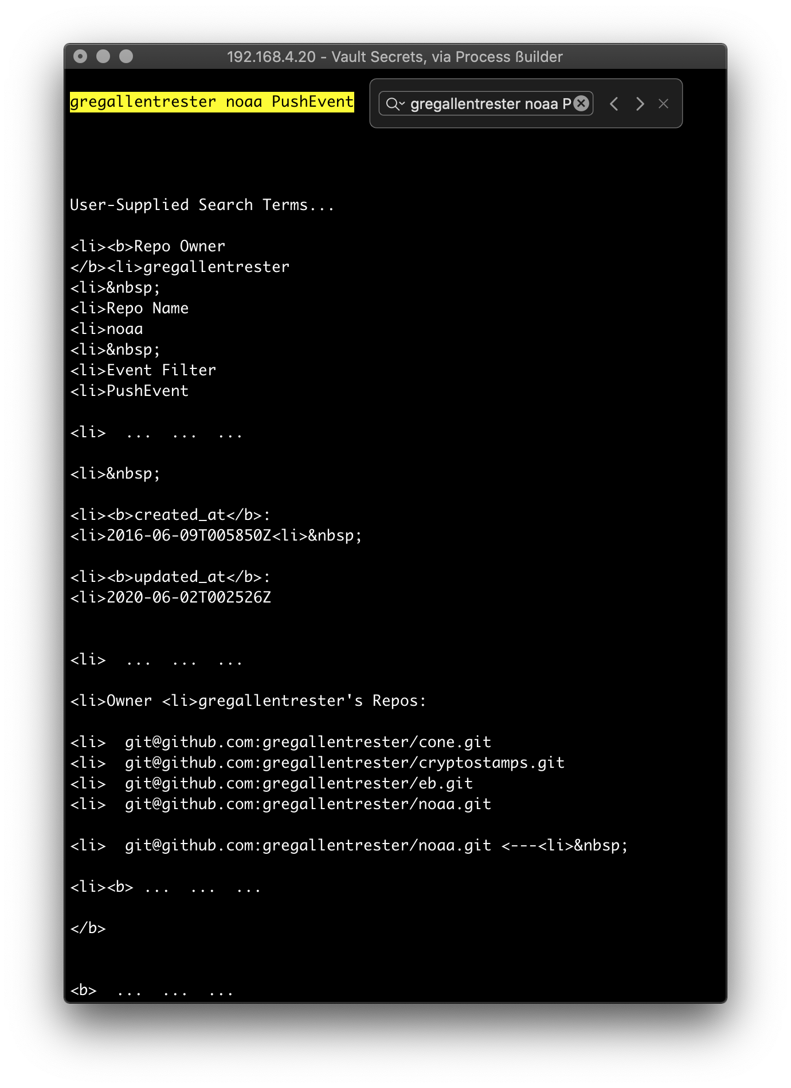

1/8, Console PushEvent

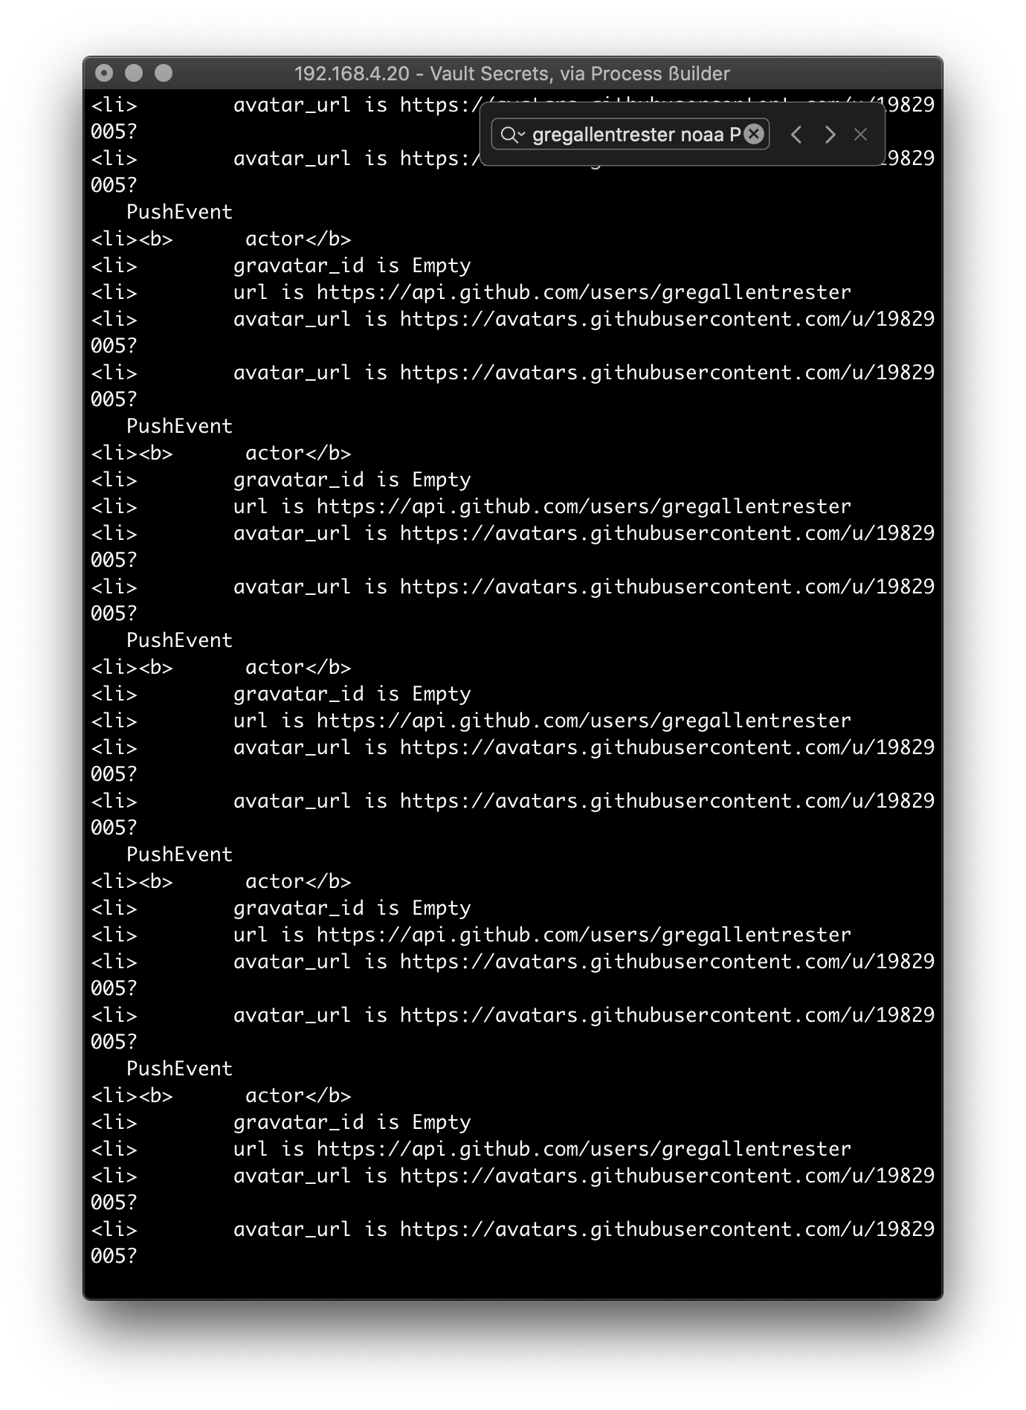

2/8, Console representation of a PushEvent

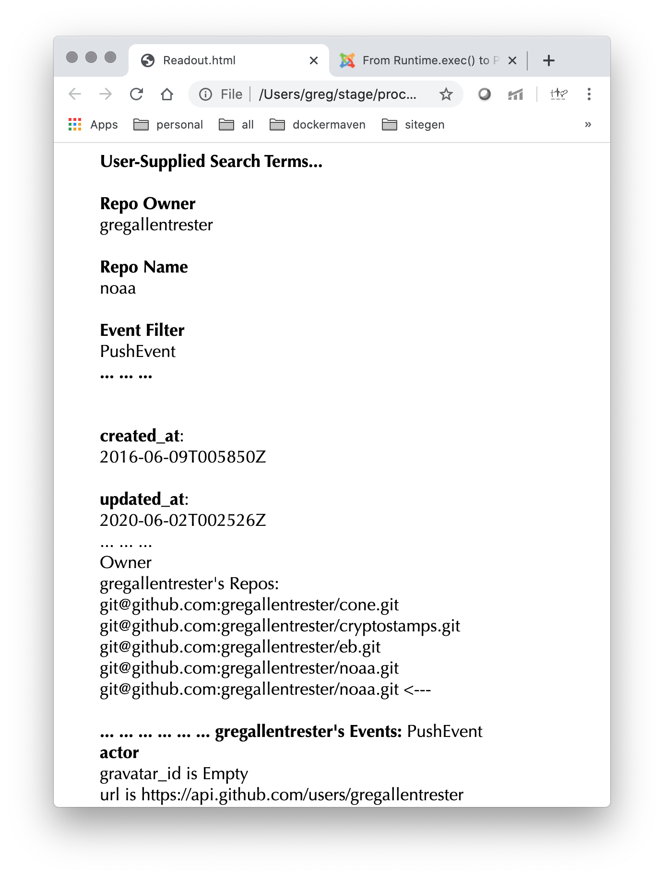

3/8, Browser representation of a PushEvent

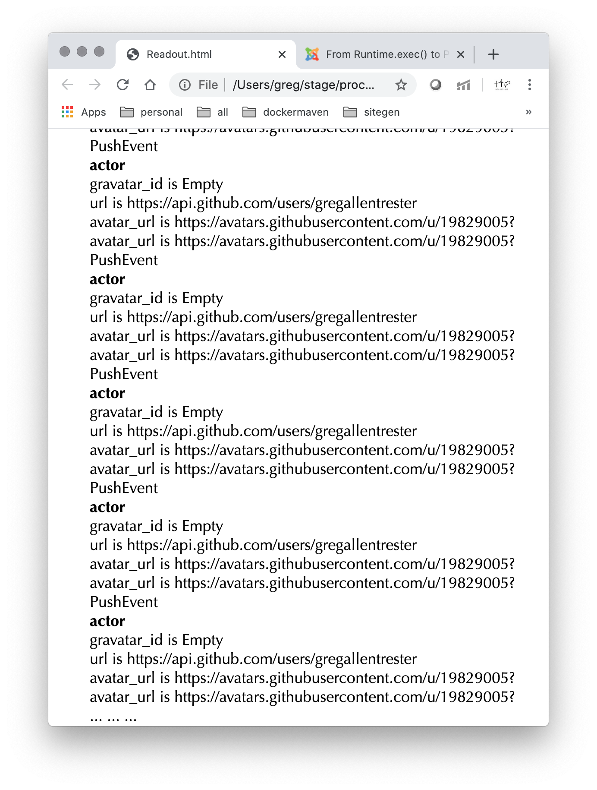

4/8, Browser representation of a PushEvent

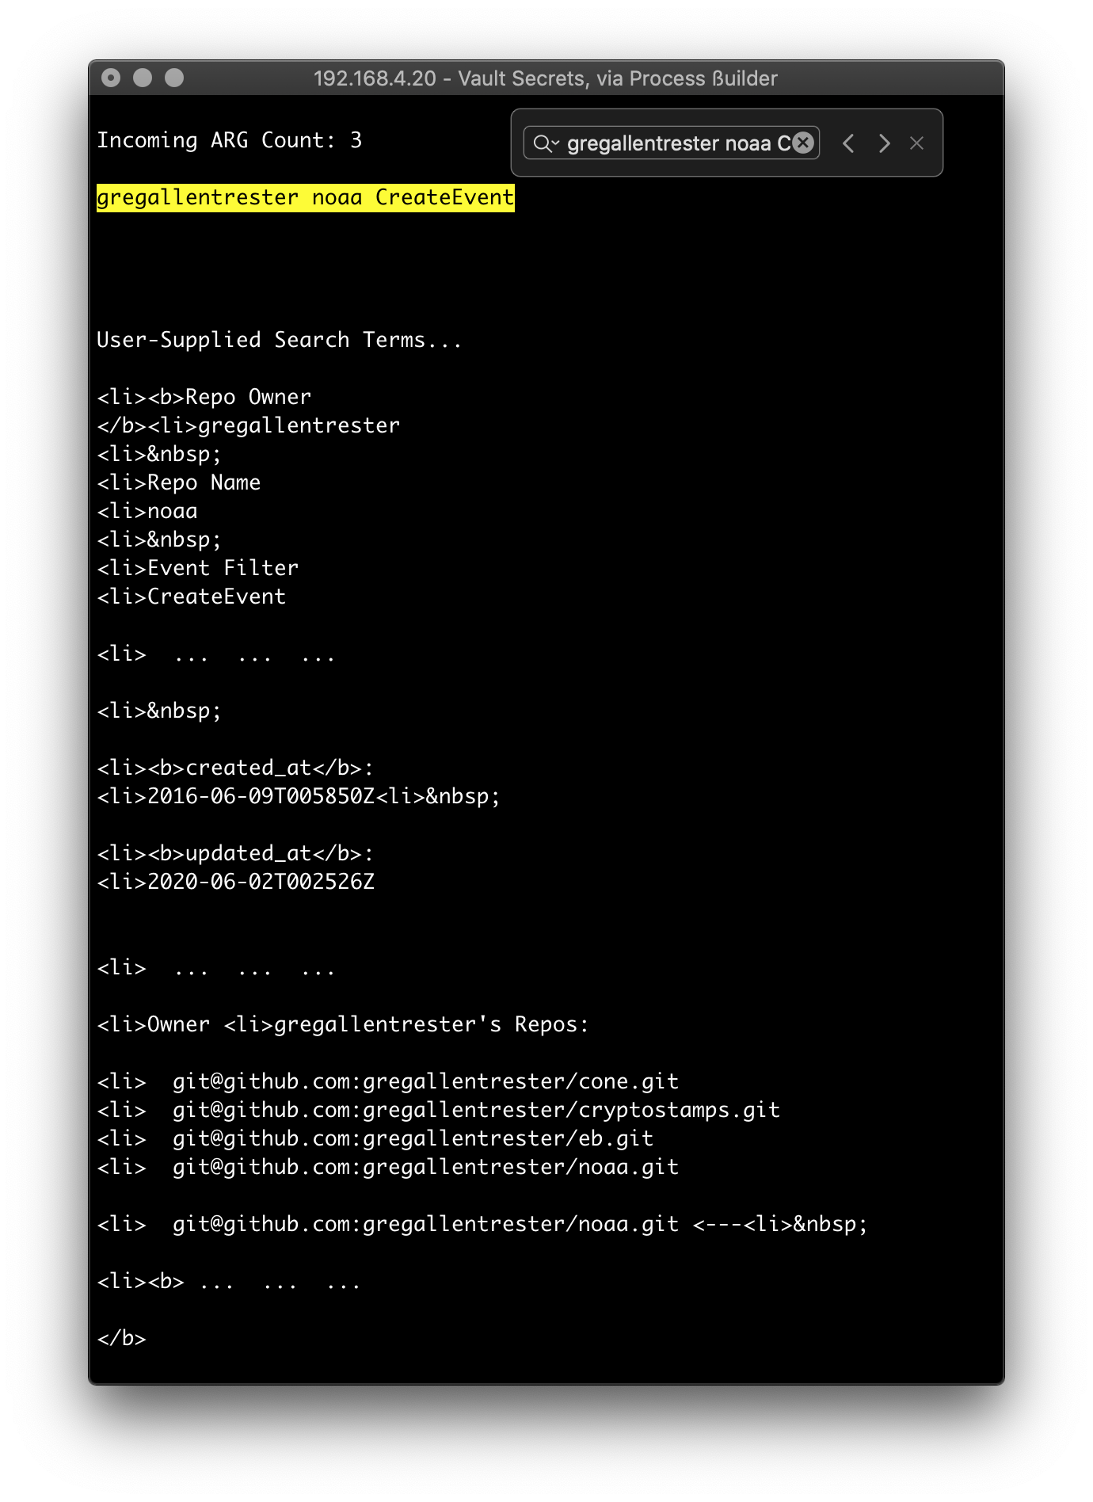

5/8, Console representation of a CreateEvent

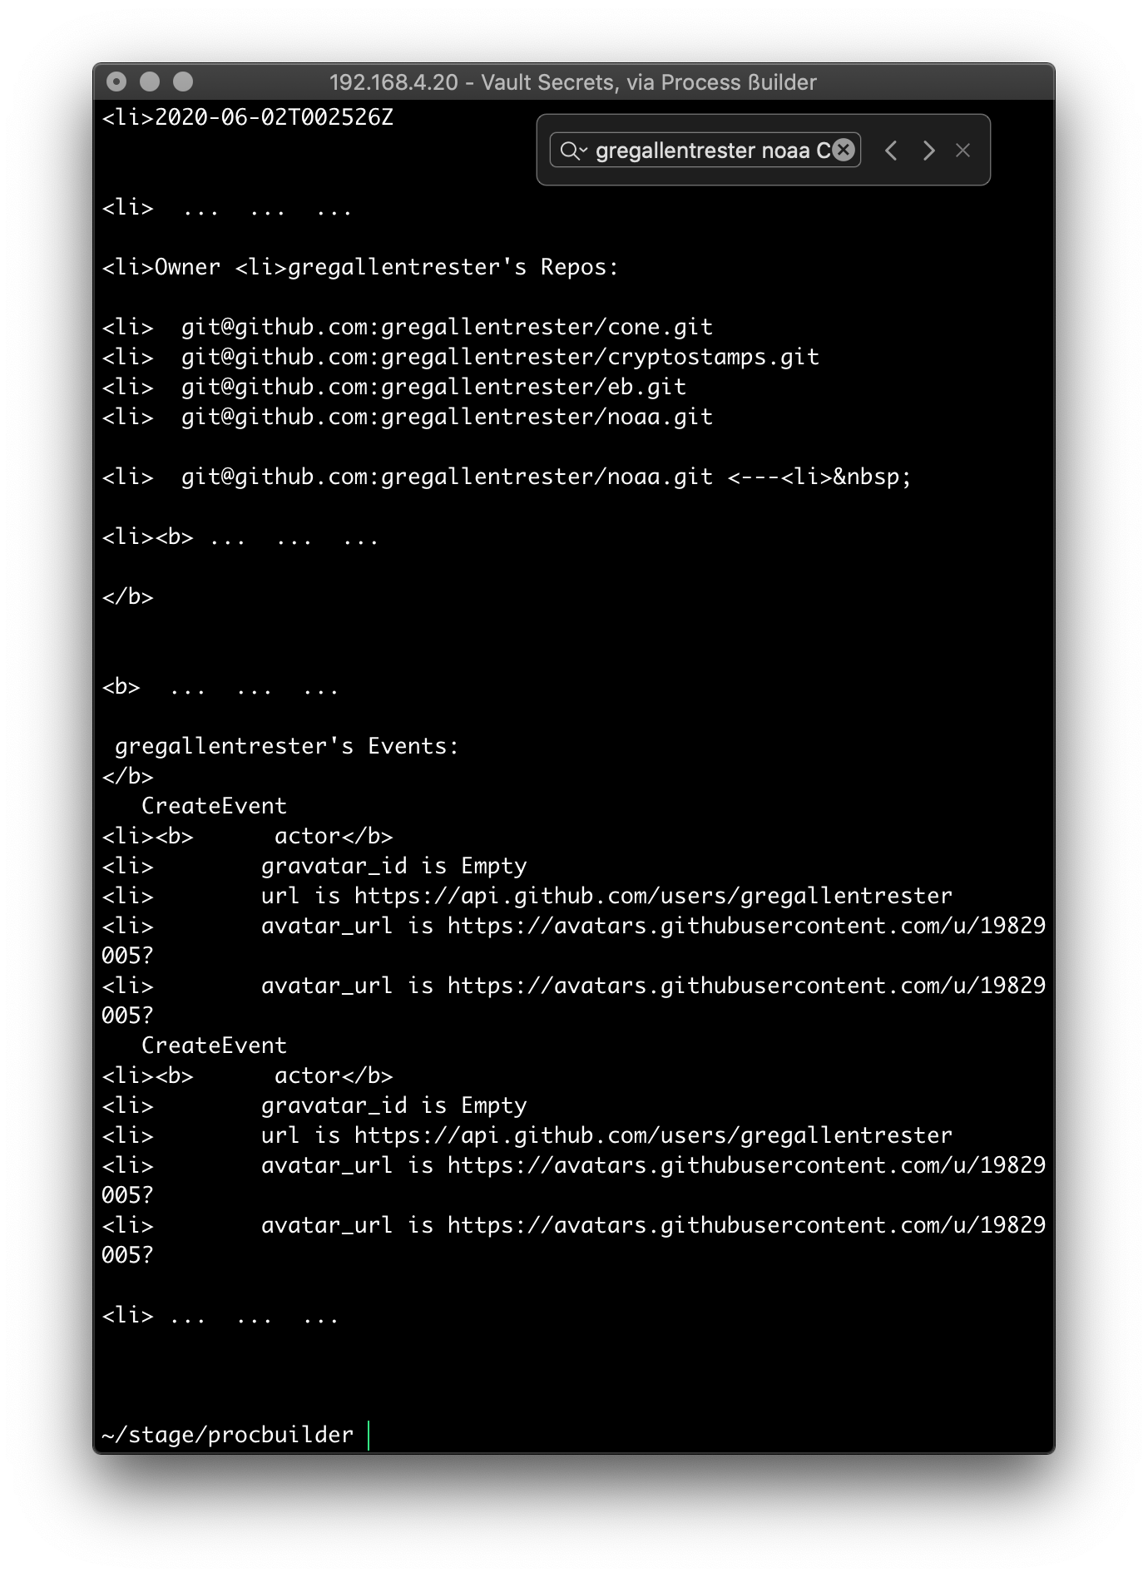

6/8, Console representation of a CreateEvent

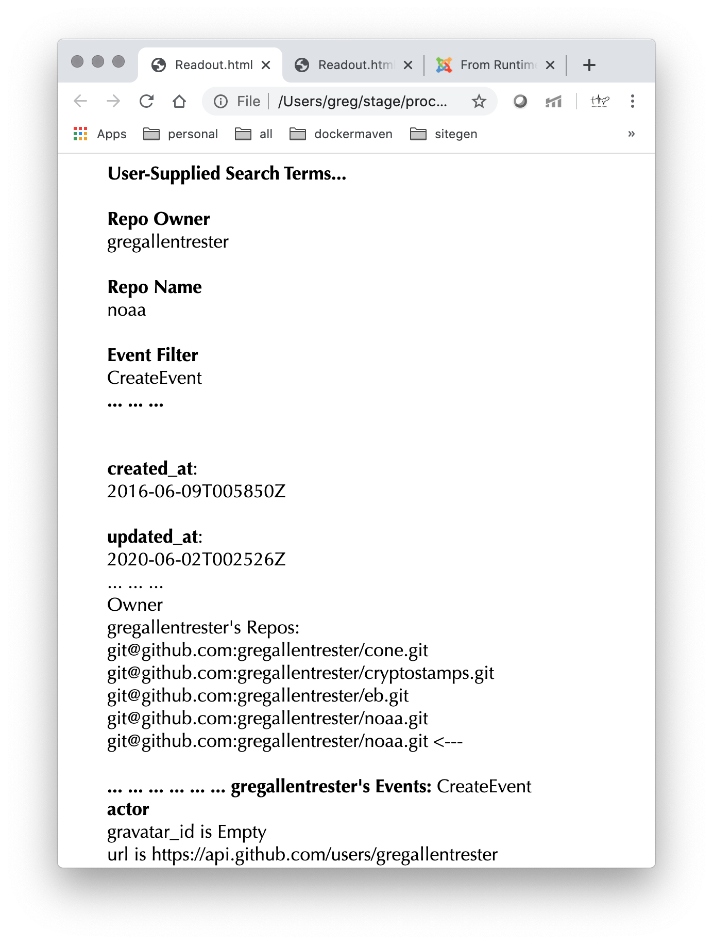

7/8, Browser representation of a CreateEvent

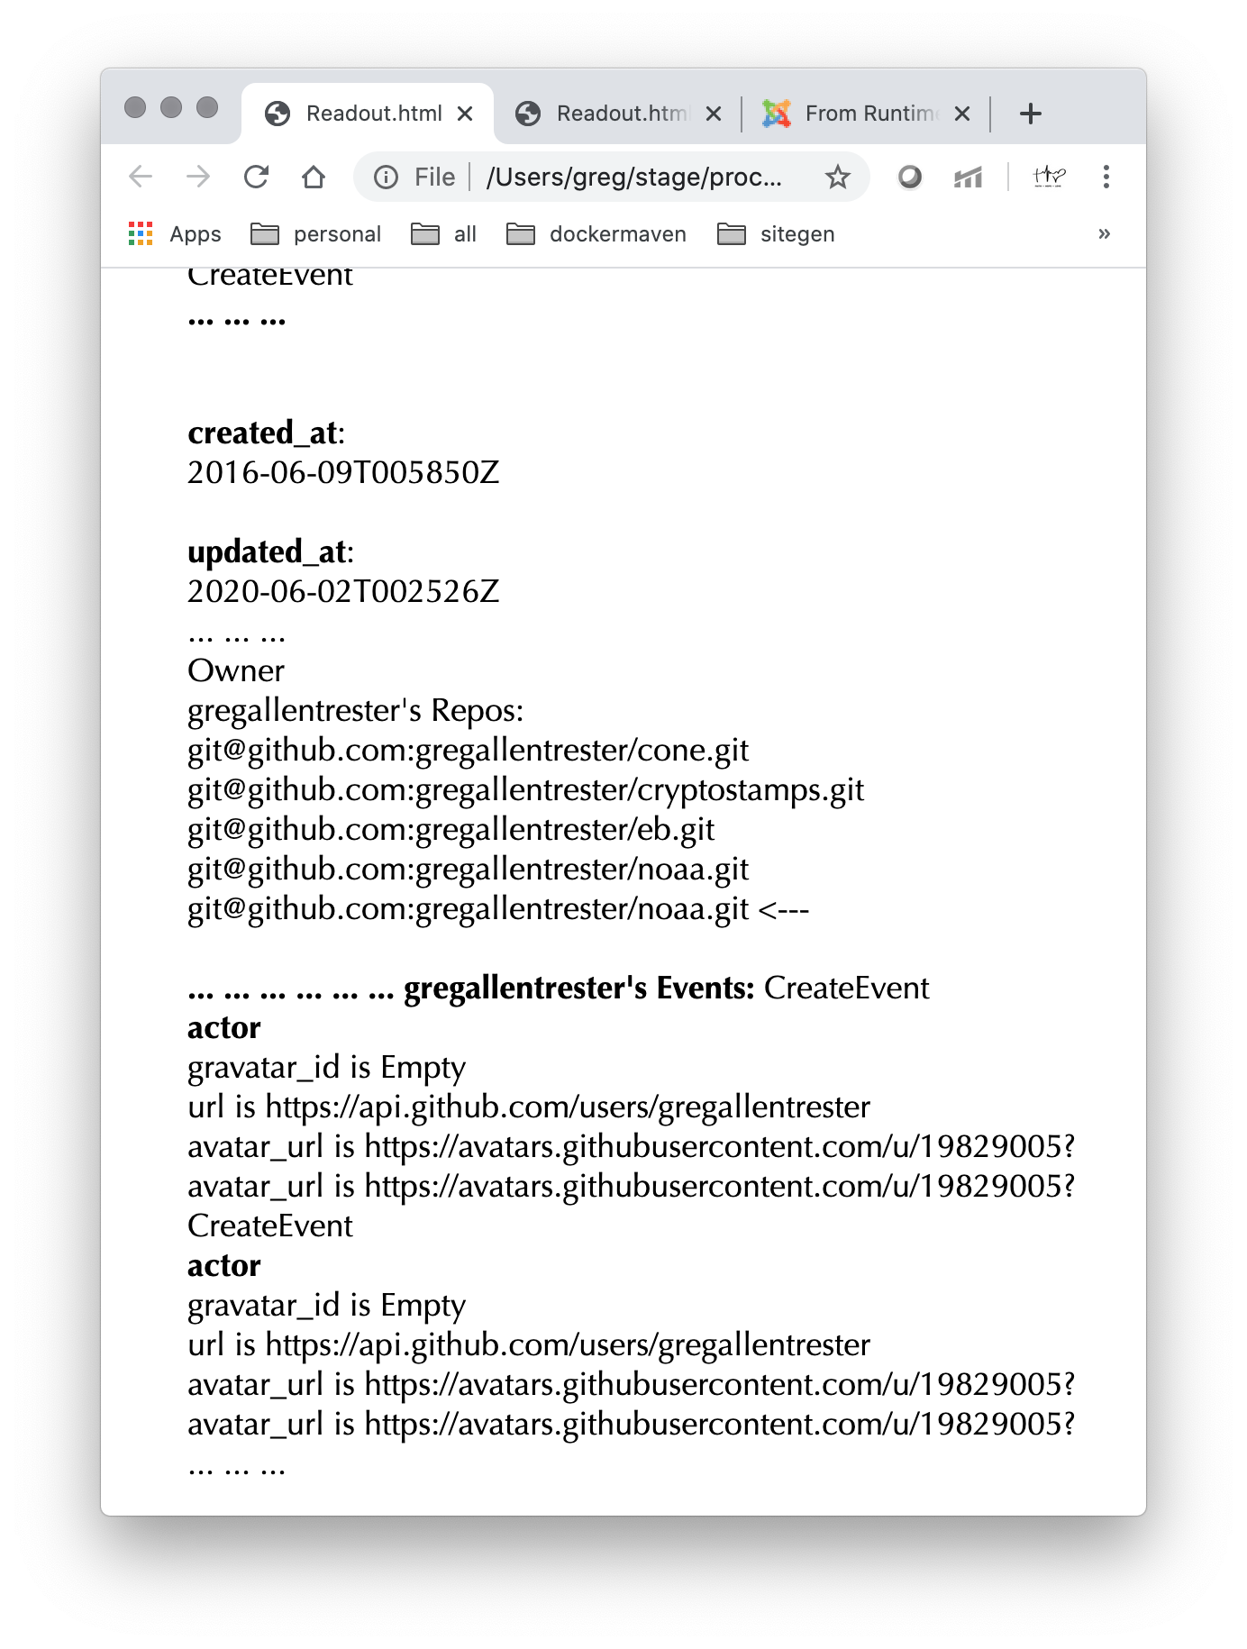

8/8, Browser representation of a CreateEvent

The Canvass Method

Partially responsible for the quick and dirty HTML markup for a web page readout to supplement a console representation of the same data.

Logic sends the markup to a flat file. A ßash script (shown below, after the Java code) publishes it to whatever browser is default for your macOS.

You have to use macOS to successfully run this application

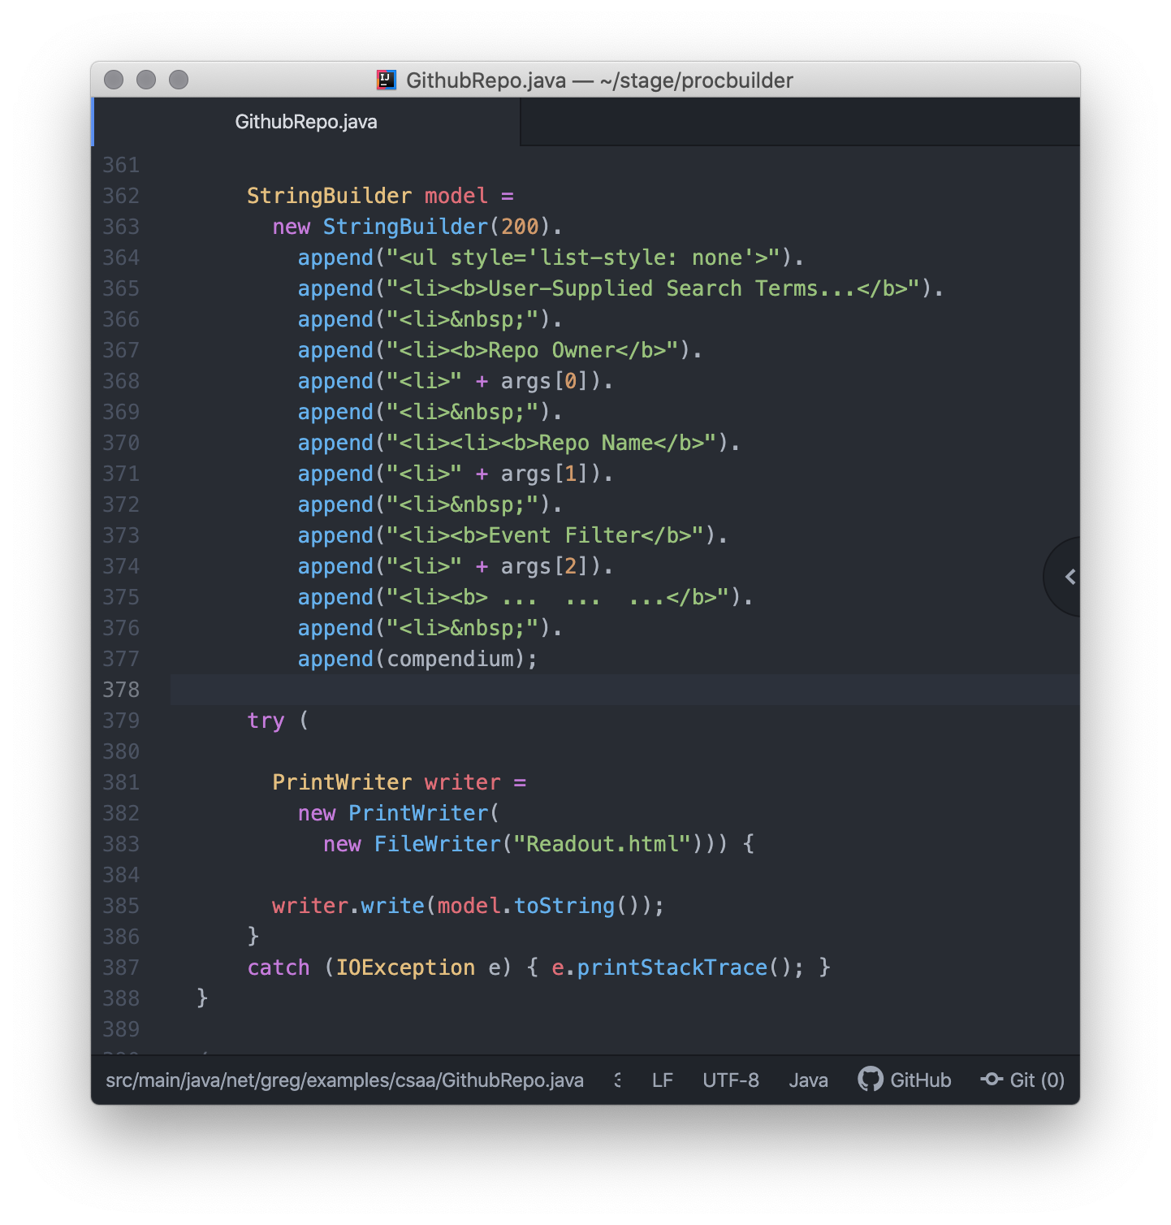

ßash Scripts Method

ßash scripts remain one of the most efficient ways to move process large volumes of data,

Much like the Java 8 leveraging of the ßuilder Pattern for streams, Linux inspired Java 8 streams by utilizing “functions”, which are sometimes called utilities, but are more properly termed Filters.

In Linux /Linux-like OSs, Filters are chained together to produce a processing stream.

This application leverages this technique for both the build and part of the core processing.

Advantages are decoupling, so in some cases there is no need to recompile for certain key aspects.



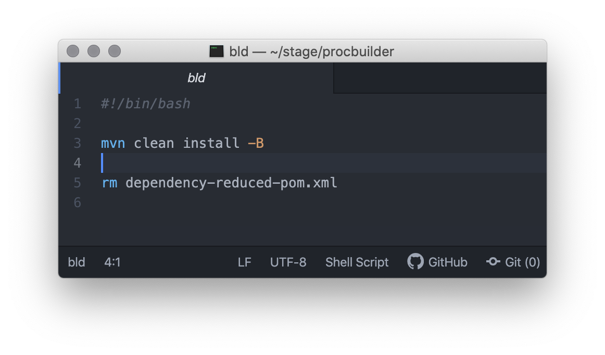

bld – ßuilds the App



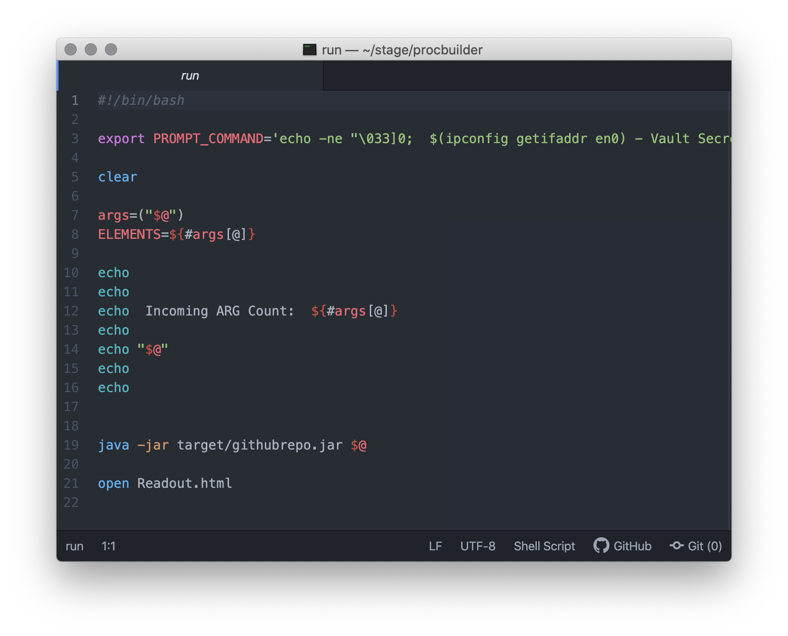

run – Executes the App (accepts any number of arguments).

Opens the application-fabricated HTML readout page

by OS’s default User-Agent (browser).



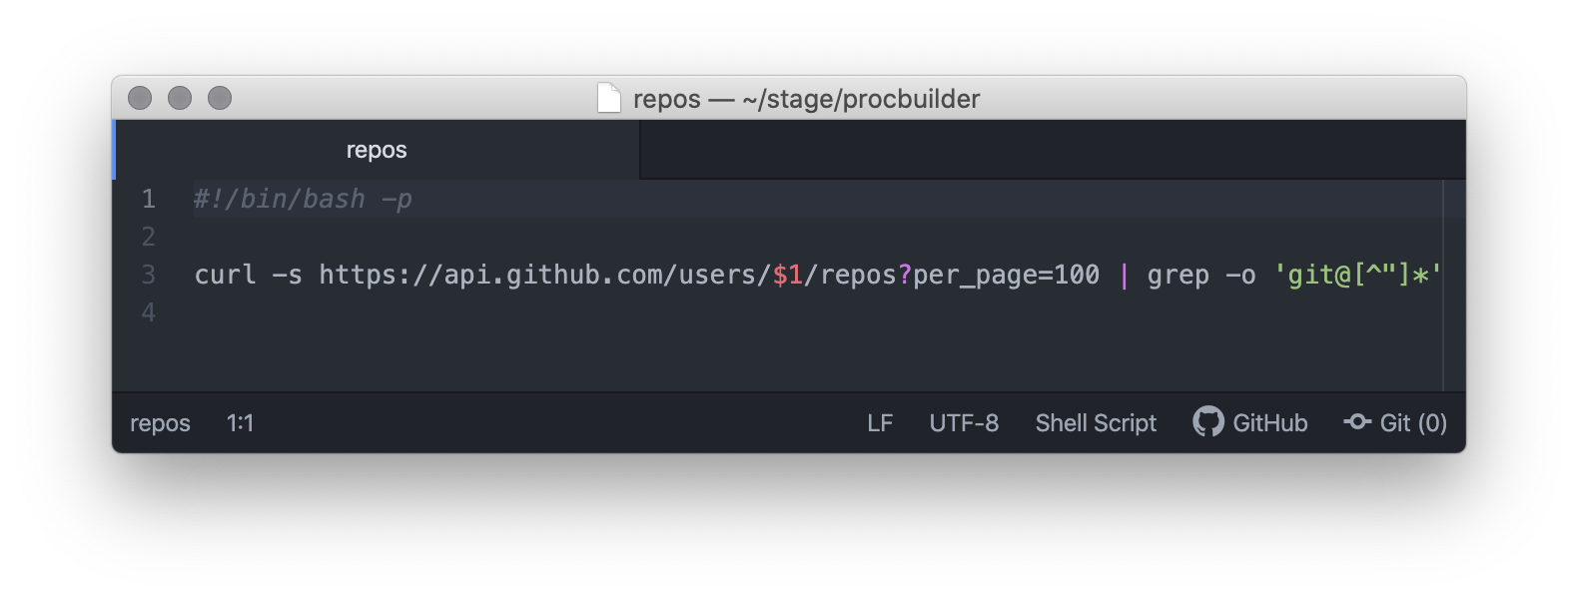

repos – ßash script which cURLs to the Github Repository

endpoint for a given Owner.

Called by a Java ProcessBuilder – Runtime.getRuntime.exec().



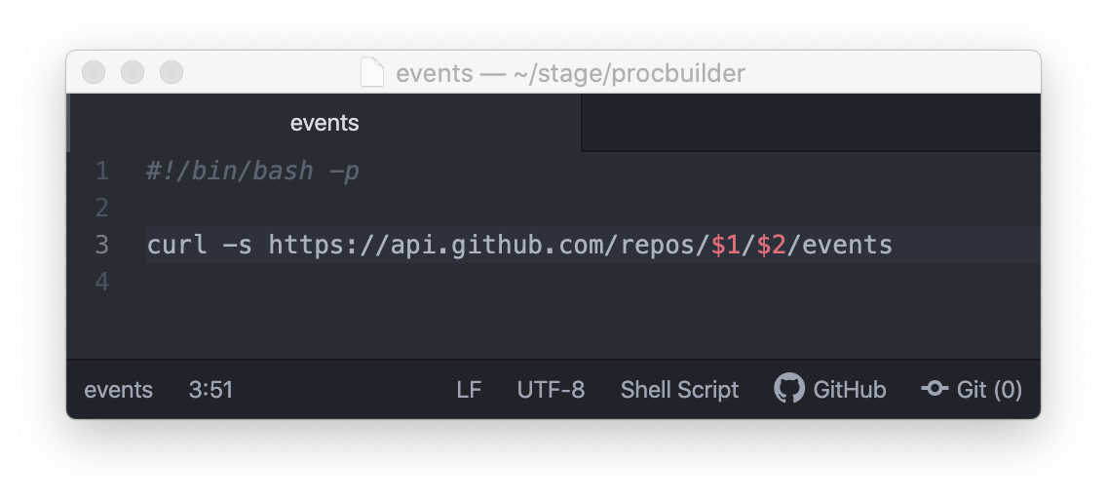

events – ßash script which cURLs to the Github Events endpoint

for a Repo, within a given Owner.

Called by a Java ProcessBuilder – Runtime.getRuntime.exec().

